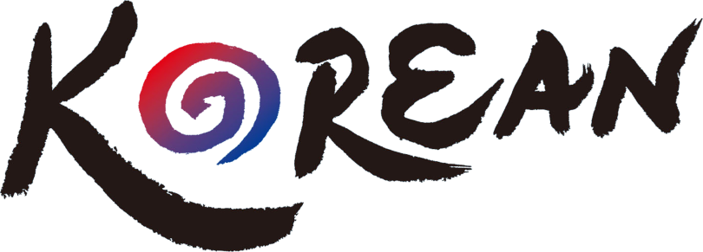
Let’s learn

2022 KOREAN LANGUAGE CLASS FUND
APPLICATION GUIDELINES

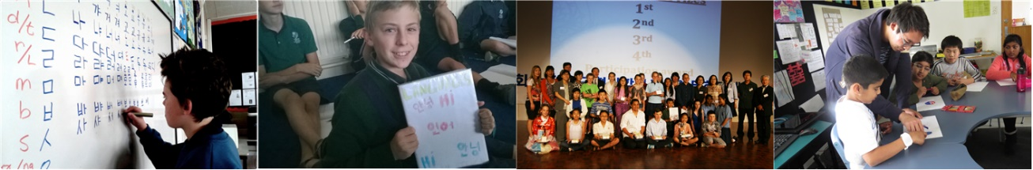

Contact Us:
Email: nzkoreanedu@gmail.com ｜ Phone: 09-303-2625
Homepage: www.nzkoreanedu.com ｜ Address: Level 7, 63 Albert St. Auckland CBD

2022 KOREAN LANGUAGE CLASS FUND
APPLICATION GUIDELINES

- FUND INFORMATION
The Korean Education Centre is a government organisation representing the Korean Ministry of Education. Since the centre was established in 2012, we have been promoting and supporting the Korean language and culture in schools in New Zealand.
Since 2019, schools may apply for additional funding through the CAPE programme* (Centre of Asia-Pacific Excellence) if they wish to teach more hours for the Korean language class.
The NZ government funds the CAPE to foster knowledge between New Zealand and the Asia-Pacific. It is committed to helping learners, teachers, and communities, particularly to improve their understanding of the Asia-Pacific and its many languages and culture.

KOREAN LANGUAGE TEACHER FUND
- The objective of the fund
- To provide and support NZ schools to establish and run sustainable Korean language classes.

- About the 2022 fund
- The Fund covers the salary of a Korean language teacher ($40.00/hr)
- KEC supports the salary of the Korean language teacher for the first 120hrs Max./year.
- CAPE* supports the salary of the Korean language teacher for an extra 120hrs Max./year.
※ CAPE’s fund will only be available until 2022. Schools will be selected based on the allocation of the Korean language class within the school curriculum, NCEA levels and sustainability of the programme after the CAPE funding.

- The minimum standard for class hours is 1 hour per week * 4 terms / 40 hours per year. However, the average is dependent on school conditions.
- In addition to the teachers’ salary, KEC supports some of the actual expenses such as teachers’ textbooks, the materials for the class, or fuel costs for long-distance commuting.
- If the schools support partial expenses above for running the Korean language classes, the schools will get preferential treatment when selected as the final schools.

- Application submission
- Submit required documents to nzkoreanedu@gmail.com. By Friday, 3 December 2021
- Required documents: Application FORM 1 & FORM 2
- Homepage: www.nzkoreanedu.com / ☎: 09-303-2625

- FUND APPLICATION PROCESS

GENERAL INFORMATION [FORM 1]
Section 1: School Information
Name of the school
The school address
School roll
Class numbers
The total period of running the Korean language classes |  | (ex; 2014 ~ 2017 / 4yr) , (ex; 2014, 2019~2021/ 4yr)
School’s accountant details |  | (The Korea Education Centre recommends that each school sign employment contracts directly with teachers, and KEC pay funding to school accounts.)
Bank name

Bank account name
Bank account number
Section 2: Korean Class Status (2021) – should be based on the most recent term
(You don’t need to fill out if your school didn’t run Korean Class , the year 2021)
Total number of Korean Classes
Total number of students in Korean classes
Types of Korean Classes |  |  | □ during school hours □ lunchtime □ after school
Section 3: Contact Teacher’s Information
(Head of Language/ Person in charge of the language program)
Contact person |  |  |  | Role:
Contact number |  |  |  | Mobile:
Email address
Section 4: Korean Language Teacher’s Information
(if known)
Contact person |  |  |  | Role:
Contact number |  |  |  | Mobile:
Email address
2022 KOREAN LANGUAGE TEACHER FUND
APPLICATION FORM [ FORM 2 ]
Section 1: 2022 Korean Class Plan
Term |  | T 1 ( ) / T 2 ( ) / T 3 ( ) / T 4 ( )
Start Date  (Expected) |  |  |  | End Date  (Expected)
Type of class |  | □ During school hours □ lunchtime □ after school
Term  1 | Duration  Weeks |  | Year  Level(s) |  |  |  | No. of  Classes
 | No. of classes per week |  | *Total teaching  hours termly |  | (ex:08:30 am.~12:20pm. 230min: 3,8hr->4hr)  (ex:08:30 am.~11:50pm. 200min: 3.2hr->3.5hr)
Term  2 | Duration  Weeks |  | Year  Level(s) |  |  |  | No. of  Classes
 | No. of classes per week |  | *Total teaching  hours termly
Term  3 | Duration  Weeks |  | Year  Level(s) |  |  |  | No. of  Classes
 | No. of classes per week |  | *Total teaching  hours termly
Term  4 | Duration  Weeks |  | Year  Level(s) |  |  |  | No. of  Classes
 | No. of classes per week |  | *Total teaching  hours termly
Total teaching hours annually :
If your school’s total teaching hours exceeds 120hours/year, please check the box below to request the KEC+CAPE fund
□ Yes, I would like to request the KEC + CAPE fund

- *Total teaching Hours Termly shall be calculated, including Prep Time.
Prep Time indicates the time spent before and after class to prepare for class and break time between classes. However, we do not include lunchtime as prep time.
- Thirty minutes will be the standard for upwards of teaching hours; up to 1 hour is recognised as the prep time a day. So, for example, if the total hours of work are 130 minutes, including prep time, we consider teachers worked for 2 hours and 30minutes on that day. (2.5 h)
Section 2: Information
◈ We Support schools teaching Korean additionally as below:
- KEC supports various K-festival cultural events such as Taekwondo, K-pop, and traditional Korean games. (September ~ November 2022: However, regions can be restrictive.)
- KEC supports Korean resources (books). (December 2022: 3 or 4 schools will be selected.)
- The best Korean language awards (November 2022: recommendation by per school)

◈ We need Schools’ cooperation:
- After each term, please hand in the term report in one week to get funded on time.
- Schools are recommended to submit an annual report on the fund by the end of the year.
- Status Survey (Term 1, Term 3):
* The Information on the interim status survey will be released separately in advance.
- KEC would appreciate it if schools could provide partial support for purchasing textbooks for teachers or activity materials for the Korean classes.

Section 3: Confirmation
Reason(s) for
applying the
programme

Principal’s Name |  | Date
Signature

